In this article I will try to give how can we change Arduino Uno to a rubbur ducky using linux (ubuntu)

so I did find some articals and video but all of them are for windows

https://www.hackster.io/aswinaK/rubber-ducky-using-arduino-593fb1
https://www.youtube.com/watch?v=tlYMNxC_Ptk

so what we need first is an Arduino uno

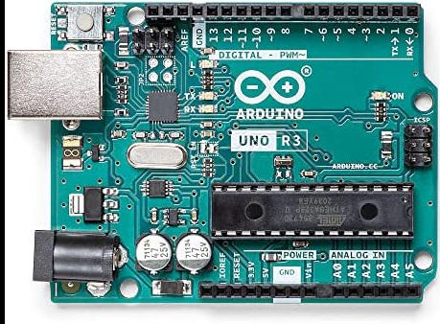

and a cable

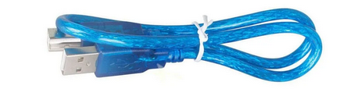

and one of this :

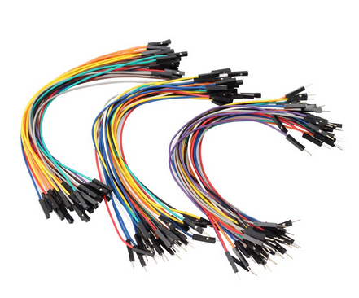

we need to download the Arduino IDE :

https://www.arduino.cc/en/software/

then we need some packages from GitHub :

1→ to flash our Arduino : https://github.com/dfu-programmer/dfu-programmer

git clone https://github.com/dfu-programmer/dfu-programmer.git
cd dfu-programmer # change to the top-level directory

./bootstrap.sh # regenerate base config files

if it doesn’t work :

sudo apt-get install autoconf

then we try again

./configure # regenerate configure and run it

If usb library is not available try getting
sudo apt-get install libusb-1.0-0-dev.
And the last thing :

make # build dfu-programmer
sudo make install # install dfu-programmer

2→ we need a library for our code in the Arduino : UNO-HIDKeyboard-Library

git clone https://github.com/SFE-Chris/UNO-HIDKeyboard-Library.git

this code is old so we need to make some changes

we go to pull request and updated edition

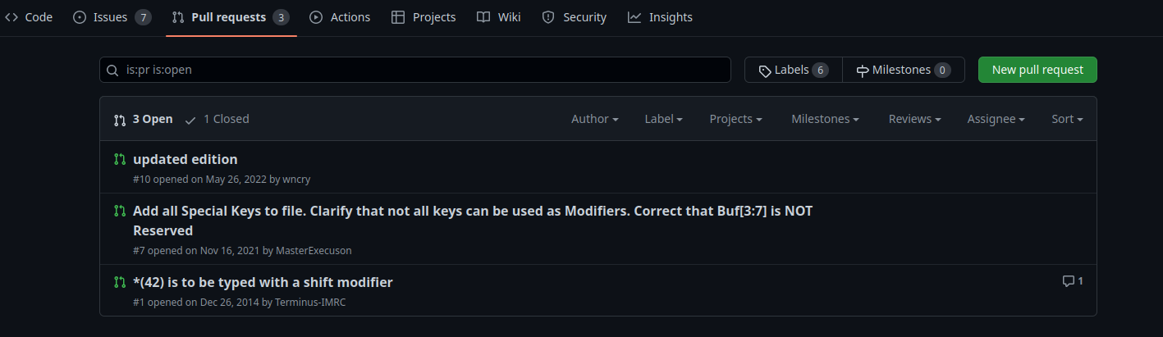
in the pull request we will see a bunch of pull request we need two of them

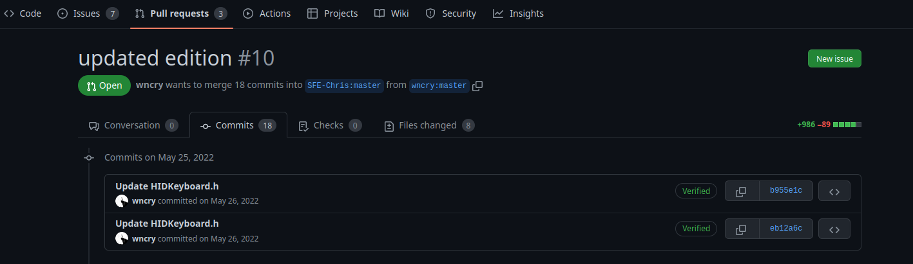
we go to the specific file : HIDKeyboard.h

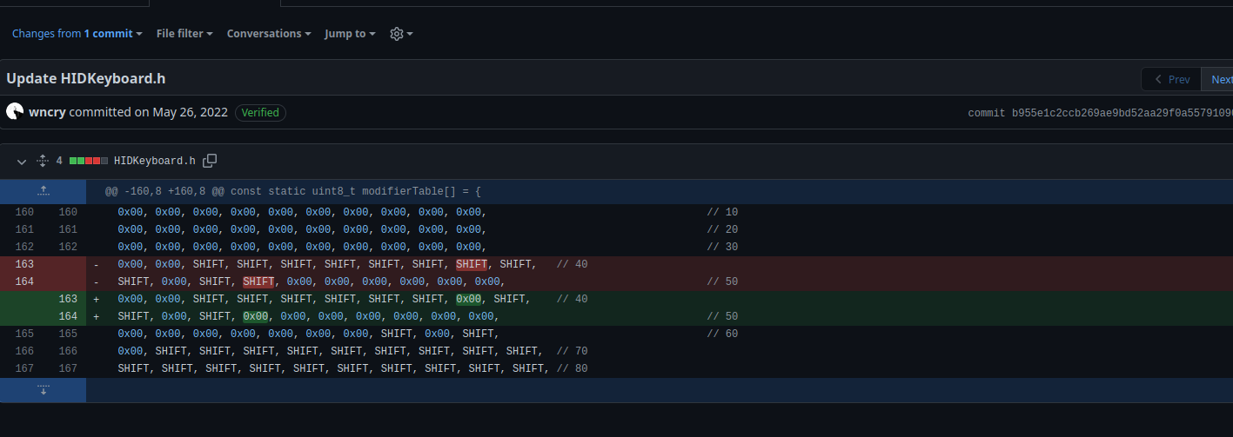
so we see we have to change this two lines

https://github.com/SFE-Chris/UNO-HIDKeyboard-Library/pull/10/commits/b955e1c2ccb269ae9bd52aa29f0a55791090c6bc

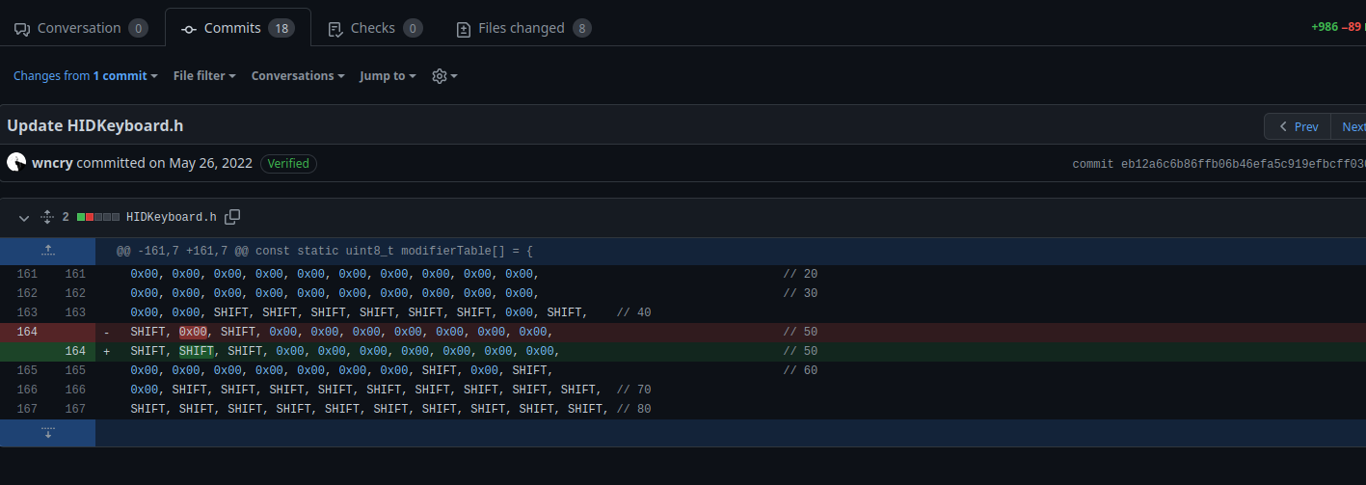
and this is the second change
https://github.com/SFE-Chris/UNO-HIDKeyboard-Library/pull/10/commits/eb12a6c6b86ffb06b46efa5c919efbcff03056a3
this will be ziped

$ zip -r <output_file> <folder_1>

We also need another zip



https://www.arduinolibraries.info/libraries/hid-project

we will include it in our Arduino IDE in the first step

3 → we need two hex file : they are the firmware

Arduino-keyboard-0.3.hex
This will allow us to go from Arduino to a keyboard
curl https://raw.githubusercontent.com/coopermaa/USBKeyboard/master/firmware/Arduino-keyboard-0.3.hex> Arduino-keyboard-0.3.hex

Arduino-usbserial-mega.hex
This will allow us to go from a keyboard to Arduino

curl https://raw.githubusercontent.com/coopermaa/USBKeyboard/master/firmware/Arduino-usbserial-uno.hex > Arduino-usbserial-uno.hex

First step :

include the two zip files in our IDE :

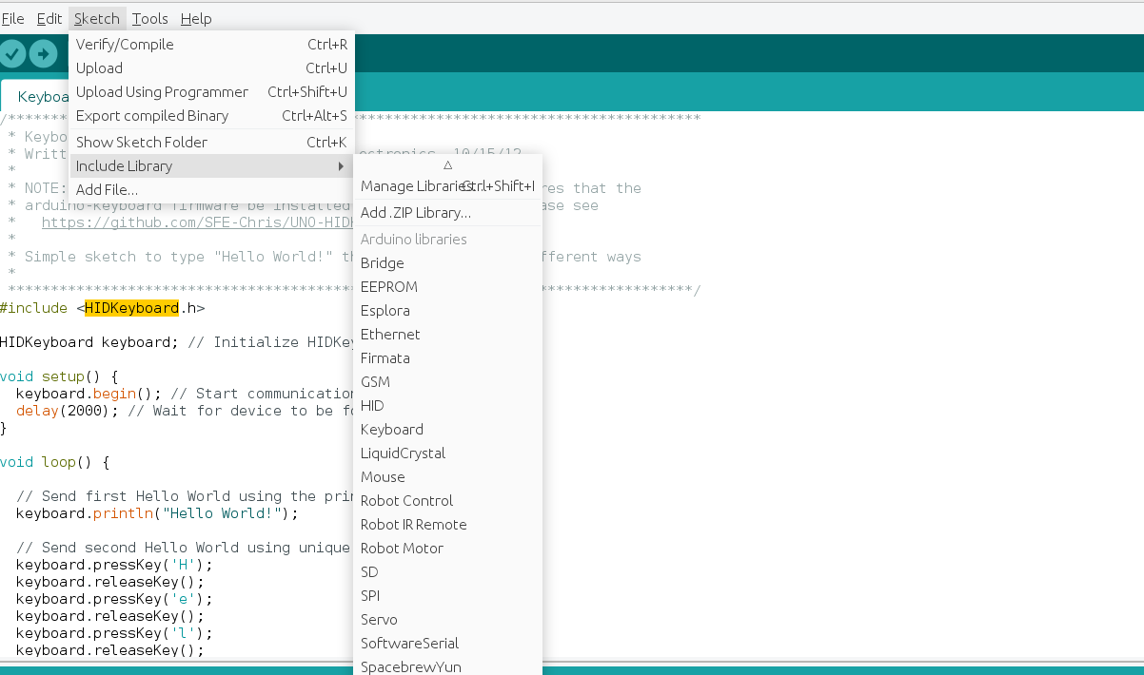
so we add the two ziped files the first for the UNO-HIDKeyboard-Library and second for hid-project

now we need a script for the arduino :

#include <HIDKeyboard.h>

HIDKeyboard Keyboard;

void setup() {
Keyboard.begin(); // Initializes keyboard
delay(200); //so we can detect the keyboard

Keyboard.pressSpecialKey(GUI); //press the gui windows key
Keyboard.releaseKey(); //Release the gui key
delay(200);
Keyboard.println("executer"); //to type the run in the windows
Keyboard.pressSpecialKey(ENTER);
Keyboard.releaseKey();
delay(1000);//Wait for the run dialog to come up

Keyboard.println("");/ /this is the powersheel script
Keyboard.pressSpecialKey(ENTER);
Keyboard.releaseKey();

}

void loop(){

}

in this place : Keyboard.println("");/ /this is the powersheel script
we can insert whatever script we want to execute

also u can change the executer with run it depend on the target machine is it in french or english

so this script will alow us to insert our powershell script into the run.exe

we have now to connect our arduino to the computer

and u have to chose the arduino uno and also the port (you will find uno near it )

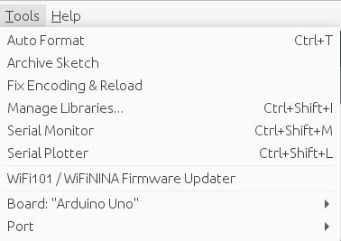

now we are ready to compile then upload the script to the arduino



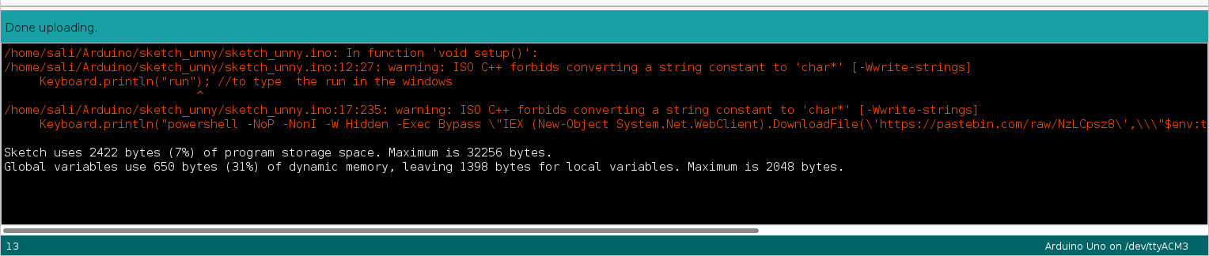
and we have to get this :

Now for the second step Which is the hardest :
turning our uno to rubber dukky

1→ we have to enter the DFU mode in our arduino

https://www.youtube.com/watch?v=aburMF2BnVo

after that we need to see our device

lsusb

we got :

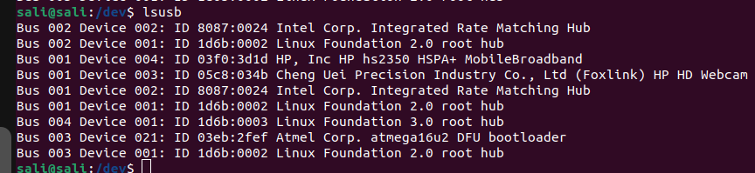

this is the arduino in the dfu mode we need “ things from this the BUS ,DEVICE , target

03 21 AND ATMEGA16U2

And now using dfu-programmer

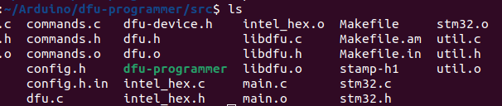
we can change the firmware

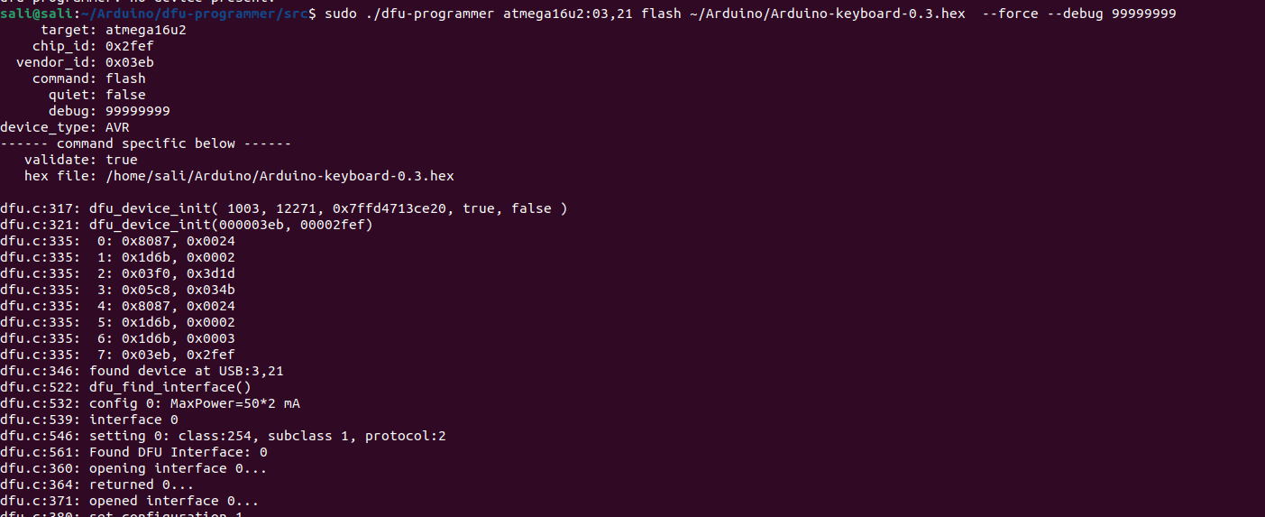
sudo ./dfu-programmer atmega16u2:03,21 flash ~/Arduino/Arduino-keyboard-0.3.hex --force --debug 99999999

so we can see here we specify the target and the bus and the device then we specify the action flash
and then the hex file

and at the end we will see a success message

in the case where we want to change the script we can return to the uno firmware by plugin the arduino going to the DFU mode

sudo ./dfu_programmer atmega16u2:0X,X flash ~/Arduino/Arduino-usbserial-uno.hex --force --debug 99999999

and now we will select the other hex file

and now we have our arduino back

hope it helps you

and thanks to these wonderful receourses

https://www.hackster.io/aswinaK/rubber-ducky-using-arduino-593fb1
https://www.youtube.com/watch?v=tlYMNxC_Ptk

